**Experiment 6:** Create a simple cloud software application for Students Attendance System using any Cloud Service Provider to demonstrate SaaS include the necessary fields such as name of the students, course, present , Absent, course attendance, OD request, grade, attendance percentage, etc.

Step 1: Creating a Application Form For Student Details.

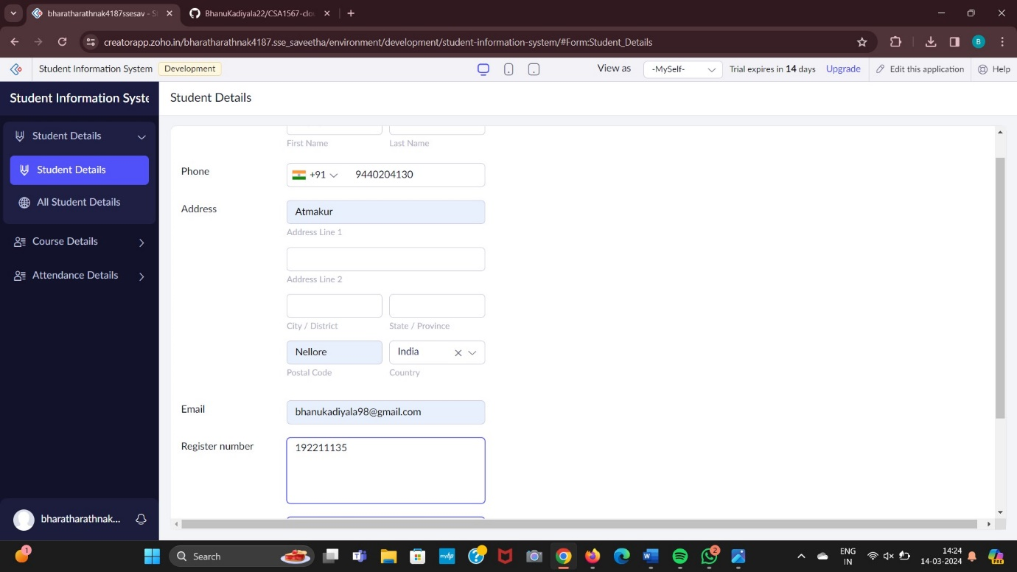

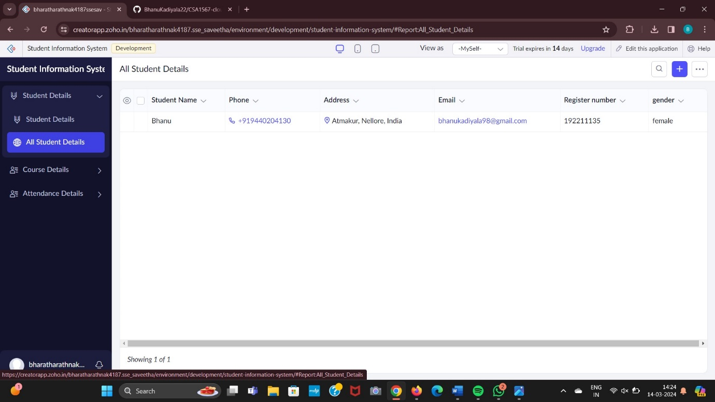

Step 2: Creating a Application Form For Course Details.

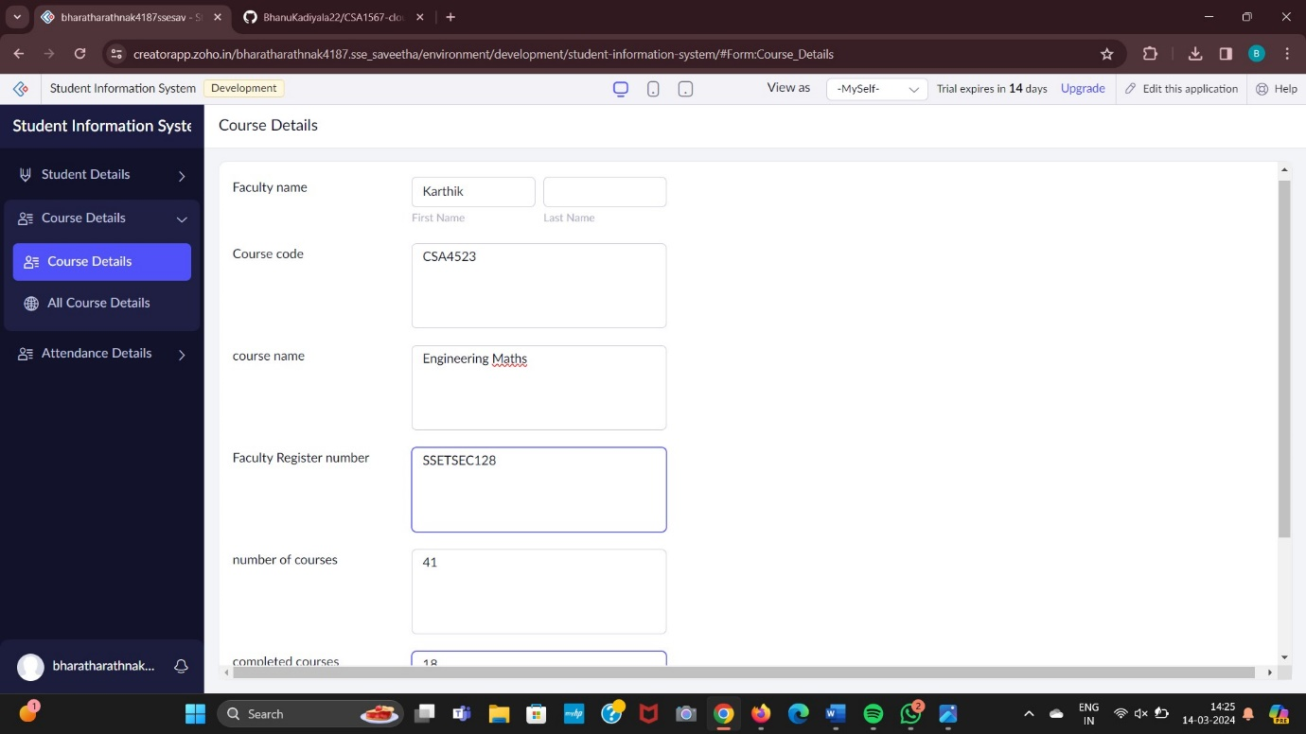

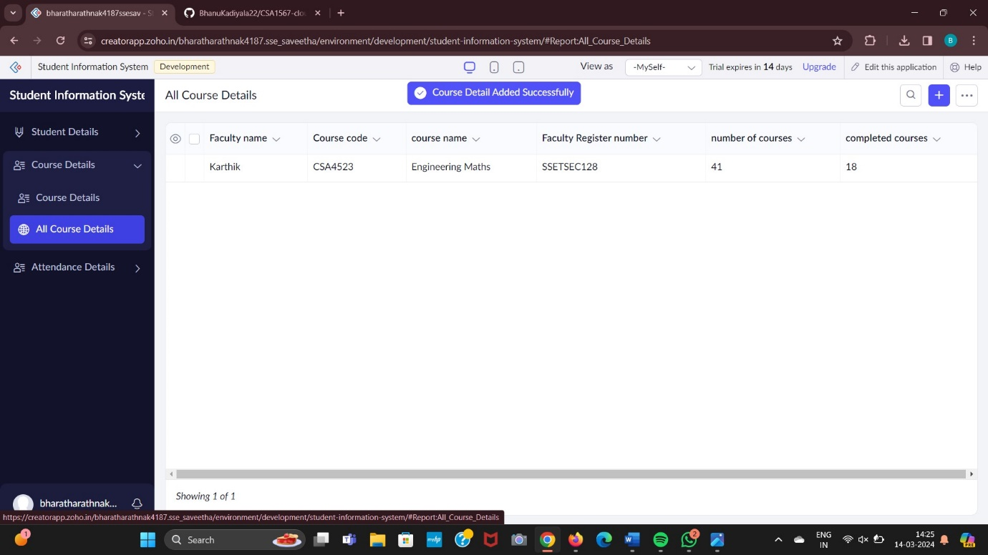

Step 3: Creating a Application Form For Attendance Details.

